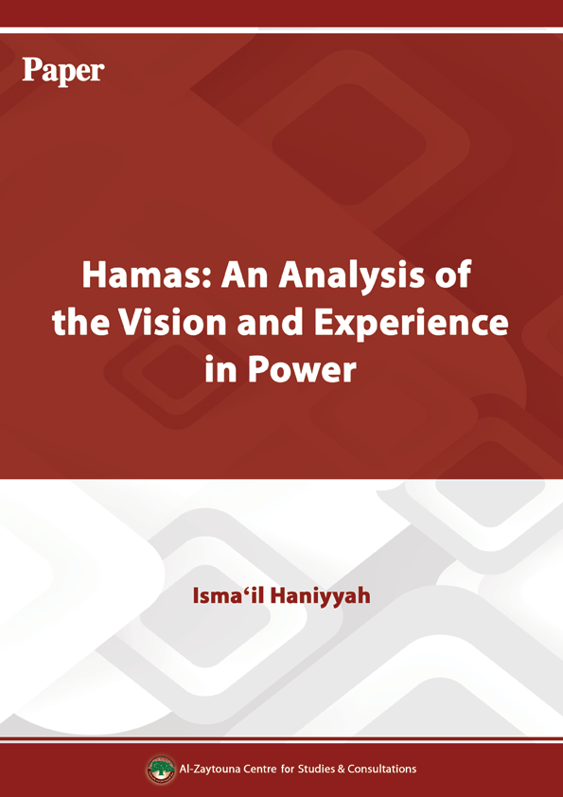
Hamas: An Analysis of the Vision and Experience in Power
Isma‘il Haniyyah

First: The Most Prominent Core Principles of Hamas
The core principles of Hamas are the fundamentals of the Palestinian people as relates to two key issues: the land and man. The land refers to the Palestinian land in its totality, and man means a free man on his free land, in a way that achieves the return of every Palestinian to his land, home, and village, where he can live freely and in dignity. It is where man enjoys his full human rights, beginning with the right to self-determination and not ending with the smallest rights, as an integral whole. In other words, our core goals, based on these principles, are: liberating the Palestinian land and the return of the refugees to live in their free land.

Second: The Elements of Power and Cohesion that Hamas Enjoys
Hamas has suffered a series of blows, each intended to be decisive in the elimination of the movement. However, providence, thanks to its commitment to the true path Allah had taught to humanity, and Hamas’s reliance on Islamic teachings and ideas, meant that it was firmly established in the hearts of stout men who were willing to sacrifice everything for the noble goals Hamas was founded to serve. It meant that the masses rallied behind these men who sacrificed all and took the path to martyrdom, beginning with the founder Sheikh Ahmad Yasin and not ending with leaders such as ‘Abdul ‘Aziz Rantisi, Isma‘il Abu Shanab, Ibrahim Maqadmeh, Salah Shehadeh, Jamal Mansur, Jamal Salim, Salah Darwazah and many others. There are also many strengths that led to Hamas’s steady growth, including the justice of the cause for which it was founded, namely the Palestinian issue with all its components. Furthermore, Hamas’s leaders and cadres have shown exceptional loyalty and dedication in defending this cause and sacrificing themselves for its sake.
The third element is Hamas’s political prudence, and understanding of jurisprudence in finding balance and identifying priorities with regard to the movement’s policies. This allows Hamas to continue to move forward without impasses, renewing itself while maintaining its authenticity of thought.
One distinguished characteristic of Hamas is its insistence on upholding the fundamentals of our people and their resistance, as the way to achieve our national goals, and its refusal to be drawn into any bargaining over these principles and rights. Nevertheless, Hamas has still shown the political flexibility required to cooperate when the situation has allowed it. Among the distinguishing characteristics of Hamas has been the movement’s reach in the Arab and Islamic worlds, which has meant that the Palestinian people are not alone in their struggle.
Another characteristic is the organizational state and the Shura-based rotation of the leadership of the movement. In addition, Hamas is known to operate in all domains of Palestinian life: Social, political, military, and security, in addition to its da‘wah activities [to invite people, both Muslims and non-Muslims, to understand the worship of Allah as expressed in the Qur'an and the sunnah of the Prophet Muhammad], allowing is to proliferate and reach new spheres.

Third: The Priorities of the Palestinian National Project
Priorities change from one period to another, each having its own requirements. The prevailing situation and national circumstances in each period place one issue ahead of the other, where these issues are part of the overall objectives of our people.
In addition, the series of major developments since 1991, the start of the Madrid negotiations and the Declaration of Principles led to the decline of a “national project” that enjoyed the support of all Palestinian forces and factions, paving the way for factional programs that aimed to achieve the general objectives and inalienable rights of the Palestinian people. Hamas’s objectives in this phase of the history of our people include restoring the unity of our people, and preserving fundamental and national rights, without compromise or concession in the current political context, which is marked by Arab preoccupation, Palestinian division, and general weakness resulting from the imbalance of power in the region. Hamas seeks to alter the balance of power in favor of completing the liberation project, and securing a life of freedom and dignity for Palestinians to become major actors in the liberation project. Among our priorities is continuing to work for national liberation side by side with building Palestinian institutions, on national foundations, be they political, administrative, or security institutions.
These issues should be addressed simultaneously, because we believe the continuation of the domestic political division and the monopoly over Palestinian decision-making are a danger to the Palestinian issue, which threatens to weaken the Palestinians’ position.

Fourth: Evaluating Hamas’s Resistance Model
Hamas presented a new model of national action not just in Palestine, but also in the Arab and Muslim region. Hamas’s model is unique in terms of the challenges it faces, and the ways it dealt with them. Although Hamas is a natural extension of the Islamic movement, its conduct on the ground differed from the approach of its parent organization. Indeed, Hamas’s activities were not limited to the charitable, preaching, and social spheres, but also focused on resistance in light of the nature of the Palestinian situation and the occupation, meaning that resistance became a priority.
Hamas was thus able to form its own model, establishing itself as a distinctive case in the Palestinian arena. Despite the sharp factional rivalry over popular support, Hamas was able to gain a significant popular weight in multiple democratic elections.
This model is a combination of resistance, da‘wah activities, relief work, popular work, political action, and intellectual action. Hamas came to have a legacy worth studying in detail in all areas, and even in its experience in power, it presented different leadership styles.
After 26 years, Hamas accumulated an experience spanning different generations, each of which influenced the movement’s history and present approach, making it an influential player not only in Palestine but in the wider region.
In each phase, its resistance model developed in a way that was politically appropriate, and that achieved the goals entrusted to the resistance towards liberation as well as the interim goals set out in the framework of its comprehensive vision.

Fifth: Hamas’s Position on Jews
We as Muslims recognize the holy books revealed by Allah and respect Judaism as a monotheistic faith. We consider Jews People of the Book, exactly like Christians who live side by side with Muslims in Palestine and various countries of the region.
Islam has stated the foundations according to which the People of the Book should be treated and respected. There is a difference between Judaism and Jews on one hand, and Zionism and “Zionists” and their occupation of our land on the other. We do not consider “Zionists” enemies because they are Jews, but because they are occupying our land and usurping our rights. Before the “Zionist” occupation, Muslims coexisted with Jews [in Palestine] without problems. Many Jews settled in the Arab world because they were protected there, while they had been massacred in Europe.

Sixth: The Position on Recognizing the “Zionist Entity,” the Peace Project, and the Bare Minimum That Hamas Can Agree On
The PLO’s recognition of the “Zionist entity” has proved to be politically disastrous. It was not a recognition of a fait accompli but a recognition of “Israel’s” right to exist, without any considerations or controls. The doors were opened wide for the occupation, and under the Oslo Accords, around 78% of historical Palestine was ceded to Israel, while the remainder was deemed “disputed territories” to be negotiated upon.
The Oslo Accords were the product of a new political era, in which the US was the world’s only superpower, and the byproduct of the Gulf war and the collective Arab shift towards the peace process post-Madrid. The Oslo Accords were not only a fundamental compromise of Palestinian rights to the occupation, but were also a source of major division in the Palestinian arena over both means and objectives, transferring the conflict into the Palestinian domestic scene. Time has shown that the peace process is a futile path that serves the interests of the occupation in accumulating facts on the ground and daily concessions from the Palestinian negotiator without any achievements to speak of for the Palestinians. In addition, negotiations have helped whitewash the occupation and its many crimes against the people of Palestine, as well as its ongoing efforts to appropriate the [Islamic] holy sites and Judaize them.
For our part, we make a distinction between political efforts and compromise; we are not opposed to any diplomatic or political efforts to restore our rights, but we are against bargaining or exchanging our rights.
There has been a Palestinian accord over establishing a Palestinian state on the borders of 1967, with the return of refugees, and without waiving the rest of our rights. The Palestinian people gives its mandate to the leadership on the basis of restoring their rights and not waving them, because it is not our own, or our generation’s alone, to give it up.

Seventh: The Experience of Hamas in the PA
1. Hamas and the Problem of Reform and Change Under Occupation
When Hamas boycotted the elections in 1996, the goal was to deny the Oslo program, which was at its peak, any legitimacy. The Oslo project wanted to enlist the entire Palestinian people in its aims, through several gateways including the elections. The PLC role was marginalized by a text that clearly stated that neither the PLC nor the PA president may issue legislation inconsistent with the agreements signed between the two sides. Moreover, the PA was not given any powers or responsibilities in international relations or economic agreements under Oslo.
However, a series of changes led us to reconsider our position in 2006, when the Oslo Accords had ceased to exist in practical terms. After 10 years of negative results and frustration among the Palestinians, the negotiations path had proven to be a failure. The PA’s poor political and governmental performance was also a factor in popular disillusionment, requiring a new force to enter the scene without the legacy of corruption that had hit many PA components. In effect, there was huge popular pressure on Hamas to stand in the election, and indeed, we ran under the slogan of “Reform and Change.” We wanted to correct some of the paths taken by the PA leadership before 2006, to protect the cause and the people from corruption and collaboration, two sides of the same coin.
Hamas was able to combine two programs and two stages, namely, national liberation with building and change. Hamas struck a practical example in its ability to fulfill this combination, as both the movement and the government underwent major existential threats aiming to thwart them. Hamas fought blockade and numerous difficult wars, and emerged more steadfast and able to offer more service to the Palestinian people. Hamas proved that where there is a real will, there is a way to advance along the two paths. Today, resistance under Hamas is stronger and better able to hurt the enemy, and has been able to impose new equations [on Israel] and undermine the fundamental foundations of its security and military doctrine.
This is due to the fact that there is a government protecting this resistance and providing it with political cover. Perhaps one of the most prominent manifestations of the integration between the political performance of the government and resistance was during Operation Stones of Baked Clay. Hamas excelled during that war, and the government played a key political role in securing regional support, protecting the back of the resistance. This would not have been possible had there not been a government with this political approach. Indeed, we have seen previous governments condemning and even aborting Palestinian resistance operations, and hence, participation in the election was a requirement for the success and advancement of the resistance program. The proof of this can be found in comparing the conditions of GS and WB, in terms of the ability and strength of the resistance.
Moreover, the Change and Reform project made important strides. In GS at least, where our government is present, corruption, excesses, and dominant centers of power have been addressed. Despite the GS blockade, there was progress in the economy, and the government implemented important measures in the context of good governance and institution building.
In the occupied WB, the problem has been that the government was not allowed to play its role because of the occupation, domestic political division and the establishment of a parallel government led by Salam Fayyad.
2. The Experience of the 10th Hamas-led Government
When Hamas contested in the 2006 legislative election, it was fully aware of the challenges it was going to face [if it won]. Hamas knew it was about to enter a new phase, and for this reason, it put forward the best of its cadres in the election. In forming the tenth government afterwards, Hamas appointed historic leaders because the task was historic. The Reform and Change program was not confined to changing names, people and their political affiliations, but it sought to change the approach and path of the national authority, in terms of doctrine, political practice, and rationale for its decisions. This would inevitably lead to the emergence of major internal and external opposition, requiring a special breed of leaders with the determination to fight.
And indeed, this is exactly what happened. The blockade began almost immediately after the election and Hamas declared its intent to form the government. Attempts to thwart the work of the government internally and externally began, and it was clear that many did not accept the results of the elections even if they had recognized them on the surface. Some sought thwart the work of the government during its early months, gambling that the government would collapse within three months.
But the government was able to withstand the attempts to thwart its work, which was manifested through security chaos and political siege, disruption in the ministries, and even military escalation.
The government formed an executive force to overcome the security chaos. Corruption was addressed by tightening the monitoring and control of the ministries and seeking alternatives to politically motivated funding, while the government reached out to many nations to break the political isolation.
The majority of civil servants did not comply with the Hamas-led government in an attempt to hinder its work and progress, and to form a parallel government at the president’s office, in addition the security forces actually worked to undermine security and hinder any achievement. Despite all of the above, the government functioned and endured for a whole year, during which it was able to prove that Hamas’s presence in power does not disrupt resistance. It soon captured [the Israeli soldier Gilad] Shalit, and proved that under Hamas’s rule, it is possible to establish diplomatic bonds with countries that do not care much about the American and Israeli siege. Hamas proved that political performance can produce changes by securing financial alternatives that would support the resistance government. A real base at the national, regional, and international levels was able to rally around this vision.
3. The Experience of National Unity Government (11th Government)
We spared no effort before forming the tenth government to have a national unity government. For this purpose, Hamas formed a special committee to reach out to national and Islamic factions, holding lengthy talks both bilaterally and multilaterally to reach an agreement. Hamas displayed flexibility with regard to ministerial posts and the program of the government, despite enjoying a comfortable majority that allowed it to easily form a majority and obtain a vote of confidence in the PLC. However, we wanted to a follow a new model in governance, in addition to ensuring integrity and good governance, namely, joint action and real partnership.
Our efforts ended in failure for multiple reasons, notably the involvement of external actors that wanted Hamas to fail. However, some potential partners were of the view that the government would not last and did not want to be part of a failed project, as they saw it, or serve as a lifeline for Hamas.
Yet, Hamas succeeded in enduring for a whole year before huge pressures that would have been enough to topple other stable administrations, including financial and economic siege, security chaos, military escalation, and disobedience by civil servants, in addition to incitement in the media and lies and fabrications meant to undermine the government and internal and external plotting. There was soon a conviction that Hamas had a lot of support and experience, enough to allow it to foil the efforts made to oust it, and some figures were prompted to accept cooperation. We communicated with those figures sincerely, and during talks in Mecca, we believed there was a good opportunity to forge real partnership in the Palestinian political arena and present the model we had aspired to a year earlier.
We wanted the national unity government to be a message to the world stressing the unity of our people and their ability to overcome the toughest crises. We wanted to say that the spirit of defiance is something that all can exhibit, especially as the agreement in Mecca had followed an Intifadah waged by all factions together against the occupation, as the Oslo option had practically collapsed under the chains of the enemy’s tanks.
However, the facts proved those expectations wrong. It seemed that there was a faction that did not accept the new reality, and thus worked day and night to sabotage Hamas. This faction linked its interests to those of the US and Israel against Hamas’s experience in power, even though it was in the context of a national unity government. The centers of power in the security forces and the Palestinian administration continued their attempts at undermining the government. Their interests dictated that Hamas had to be removed and the previous model restored.
These efforts were led by the security forces, which seemed to be determined to drag the country into organized chaos, mayhem, and bloodletting, by deploying unnecessary checkpoints, deploying on rooftops, and spreading terror among the citizens.
This necessitated a security campaign by the Executive Force, to eliminate tension hotspots and rogue elements. The campaign lasted three days and culminated with the full surrender of these elements in GS, on 14/6/2007. It was hoped that this step would be welcomed as one that had imposed order and stability in GS. However, the subsequent decisions of the president created a new reality and two parallel governments in GS and WB, disrupting the work of the PLC and ushering in the phase of division. This division can be traced back to the fact that Fatah led by Mahmud ‘Abbas had rejected the results of the [2006] election from the beginning.
4. The Experience of the Hamas Caretaker Government 2007–2013
This phase carries dual connotations. True, there were and there continue to be immense difficulties and challenges, perhaps the toughest in the history of our people. But our people made great sacrifices and showed unlimited steadfastness and patience, exceeding all expectations. Against their pain, there was hope, and the government and the people together were able to present a great Palestinian example of heroism.
This stage began with the tightening of the blockade, in an unprecedented way and from different directions. Attempts to strangulate GS began, with many goods, food, clothes, fuel, and medicines disappearing from the Strip. Electricity was cut off from people’s homes, and GS turned into a large and isolated prison; it seemed that the politicians implementing the GS siege, in Palestine, the Arab countries concerned, and internationally, had lost their humanity.
However, the resourcefulness of our people exceeded those of the leaders. The masses broke the siege, with 750 thousand people overrunning the border with Egypt, entering El-Arish (45 km inside Egyptian territory). They bought Gaza’s needs within three days, and all returned safely to Gaza without committing a single crime, setting a unique moral example. Their resourcefulness continued with the tunnels that soon became a lifeline for Gaza. During this same period, the majority of civil servants in all sectors refrained from carrying out their duties, in an attempt to disrupt the public sector. This included teachers, doctors, nurses, judges, lawyers, police officers, and other public sector employees.
Many civil servants left their jobs to spread chaos and restlessness among GS citizens. However, within three days the government was able to replace them and get the public sector kickstarted. Hundreds of people volunteered in the posts on a pro bono basis, to maintain the stability of GS and the functioning of all sectors.
The failure of all these attempts forced Hamas’s opponents to resort to their final option to topple the Hamas-led government completely: military force. In late 2008 and early 2009, through 22 days of continuous aggression, Israel waged the most violent war in the region since 1967 on GS. Israeli warplanes spared no part of Gaza, turning the Strip into a bloodbath. The assault proceeded by land, sea, and air, but was met with legendary endurance by a virtually unarmed people, equipped with relatively primitive weaponry, who gave the world this message: we are alive and have the will to survive, and shall never surrender. In the 22 days of the assault, 1,500 people died, 5 thousand homes were destroyed, and 10 thousand people were injured. Eventually, Israel halted its assault without achieving any of its objectives. Neither the government was toppled, nor was Shalit retrieved, nor was the resistance defeated as it continued to fire rockets on the areas in range from Gaza, even after Israel declared a unilateral 12-hour ceasefire. The resistance refused to accept Israel’s conditions for a ceasefire, and so this aggression and terrorism against the Strip stopped unilaterally.
After this failure on the part of the conspirators, the equation started to change. The siege began to erode, especially after Israel’s foolish assault on the Gaza Freedom Flotilla bound for GS, killing nine Turkish solidarity activists. The blockade turned into a major humanitarian issue and a political crisis with countries that for a long time were classed as Israel’s friends. These developments led to the re-opening of the Rafah crossing intermittently. National dialogue rounds began in Cairo, which restored relations with Gaza after an estrangement that had lasted nearly two years. The government developed its performance in all areas with a focus on good governance, transparency, justice, and administrative reform. The government proceeded to rebuild the entire administrative system, and launched the reconstruction of GS to repair what had been destroyed by the occupation’s assault.
There were successive victories by our people, government, and resistance. The Devotion to the Free Prisoner swap deal secured the freedom of 1,050 prisoners, some of our finest men, who were detained by the occupation, spreading joy in every home in the GS. Gaza became a Mecca for the free men and women of the world, with dozens, possibly hundreds of delegations visiting from all around the world to express solidarity, including Arabs, Muslims, Europeans, and Americans, all carrying with them projects as well as moral and material support. Gaza became a symbol of pride, dignity and human freedom. The difficulties that Gaza and its government faced turned into a blessing, with Allah elevating this small enclave in importance and significance thanks to the jihad, sacrifice, and steadfastness of its people against conspiracies and injustice.
The occupation attempted to spoil the feeling of triumph and break the will of the Palestinian people, by assassinating one of Hamas’ senior leaders, Ahmad Ja‘bari and then waging a second war. However, Israel once again was caught off guard, as weak and besieged GS led fierce resistance against Israel and challenged all its security doctrines. The resistance, for the first time in the conflict with Israel, bombed Tel Aviv and Jerusalem, downed planes, targeted warships, and destroyed tanks.
Moreover, the government continued to function, and the GS’s markets, bakeries, and streets remained stable with all government departments operating under alternative plans, leaving the enemy dumbfounded. Political action intersected with administrative operations and resistance work. Soon, the prime minister of Egypt, the Arab League foreign ministers, and the secretary-general of the Arab League travelled to Gaza along with the Turkish foreign minister following a series of contacts made by the Hamas-led government and intensive efforts that culminated for the first time with an agreement to stop the assault on GS. The resistance achieved a political victory for the first time in the history of the conflict with Israel, thanks to the integration and harmony of national action.
That war reinforced the conviction that it is possible to combine and integrate government and resistance, and that this in fact is the most appropriate situation where resistance is given political cover, and that real achievements can be made.
Today, there is a strong government. All attempts to foil its work or drive a wedge between it and the people have failed. It has been able to achieve security for the citizens, and carry out a series of strategic projects in GS. Under the Hamas-led government, GS has enjoyed a kick-start, with agricultural projects developed and achieving self-sufficiency in many types of vegetables and fruits. Hitherto abandoned factories have been restored and reopened.
All this has happened at a time when the government remained under siege and subject to various plots, and was boycotted by Arab and Western nations. However, its legitimacy and its capacity to act stem from the faith of the people, and their trust and appreciation.

Eighth: Evaluation of Hamas’s Relations with Fatah and the Palestinian Left
- The Relationship with Fatah
The Fatah movement is a national movement that has led national struggle in important and sensitive periods in the history of the Palestinian issue. However, political developments led to a political rivalry with it and a difference in approach, most notably after it agreed to sign the Oslo Accords and to enter the slippery slope of negotiations.
We seek, through reconciliation, to bridge the gap between us, not in order for Hamas to become Fatah or Fatah to become Hamas, but to coexist and for democratic mechanisms to arbitrate between different political visions and programs. Each must respect the opinion of the other, but in the end, we must all bow down to the will of the Palestinian people who should choose their political path and leaders through the ballot boxes.
We are not in a state of enmity with Fatah, albeit the differences between us led at one stage to armed conflict as a result of developments dictated by the moment and the political dynamic, which we looked at in detail earlier. Fundamentally, we are partners in the same homeland, and we must both work to achieve real partnership. To embody what we always called for; partners in motherland, partners in blood and partners in decision.
- The Relationship with the Left
Hamas’s relationship with the various components of our people and its forces and factions is based on mutual respect. These forces all have a history of an exceptional national role and struggle, and continue to be part of the struggle for Palestine. Our relationship with them is based on partnership in shouldering national responsibilities, albeit our relationships have been marked by periods of accord and others of difference. In the end, we are part of the same national direction, and we respect our ideological differences, knowing that diversity, and even competition for the sake of Palestine, is in the nature of things and commendable, as long as we have good faith in one another.
We have worked with these national forces as part of the Supreme Follow-up Committee of National Forces, and before it in the Ten-Faction Coalition and in the alliance of rejectionist forces. We continue to meet to coordinate joint action, and we hope to improve and develop our national relations. The left is the backbone of the “third current,” and has played an important role in the political arena recently. We have worked hard to build a special relationship with the left in the context of the supreme Palestinian interest. We also should not forget that the left is an important and active part of various civil society groups—legal, health, social work, etc., which have had a positive role in breaking the GS siege.

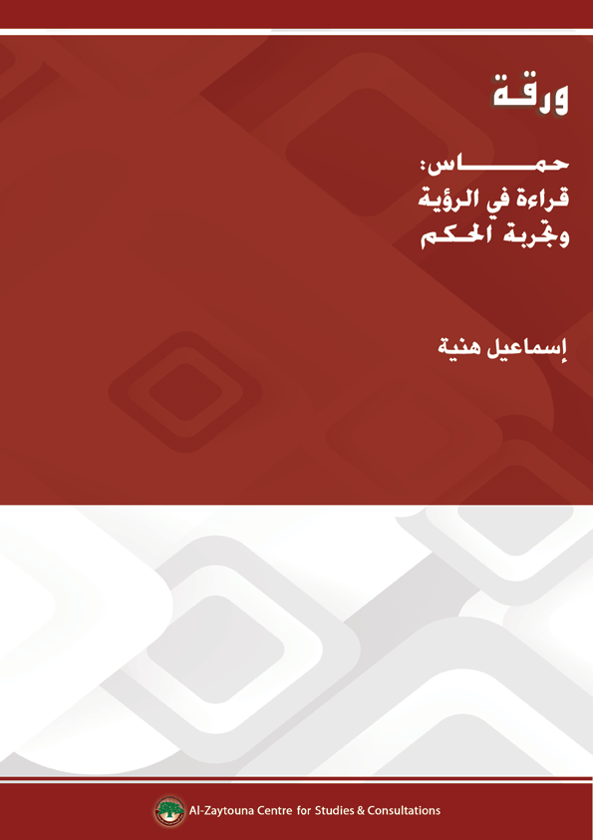

This is the text of interviews conducted via e-mail by Mohsen Muhammad Saleh from Beirut, Lebanon, with Isma‘il Haniyyah in Gaza, Palestine. Correspondence began on 19/12/2013, and the text was approved by Mr. Haniyyah on 11/3/2014. The questions and answers were placed here in the form of titles to facilitate the readability of the text. This paper was published in the Arabic Version of the Book: Islamic Resistance Movement-Hamas: Studies of Thought and Experience (pp. 479–493), edited by Dr. Mohsen Mohammad Saleh. Al-Zaytouna Centre for Studies & Consultations published the Arabic version in 2014, and the English version will be published soon.
Isma‘il Haniyyah is the Deputy President of Hamas. He holds a degree in Arabic Literature from the Islamic University in Gaza. After the release of Sheikh Ahmad Yasin in 1997, he became his chief of staff. After Hamas won the majority of seats of the Palestinian Legislative Council in 2006, he served as prime minister of the Palestinian Authority and headed the tenth and eleventh governments. After the Palestinian internal crisis, he continued to serve as caretaker prime minister in Gaza Strip until the formation of the National Unity Government on 2/6/2014.
The war was named by Hamas as Stones of Baked Clay, while the Israelis dubbed it Operation Pillar of Defense.

